**Job2913 Training Specification**

**Scope:**

Scope of the project is to assign addressing for the entire country of Oman (Oman Sultanate) for the existing base map with Unified Addressing System (UAS).

**Definition of an Address:**

The address unit in the Unified Addressing System is define as a public delivery location for goods, services and or people. Public means before entering the private domain i.e. the entrance door to a building, entrance to a gated compound, the shared gate of two villas etc.

There are many type of addressing systems existing in the World. For the Sultanate of Oman, we will be following the Unified Addressing System (UAS)

**Key Objectives:**

The key elements to be required for the addressing to work smoothly are:

• Governorates

Entire Oman Sultanate is divided in to 11 Governorates.

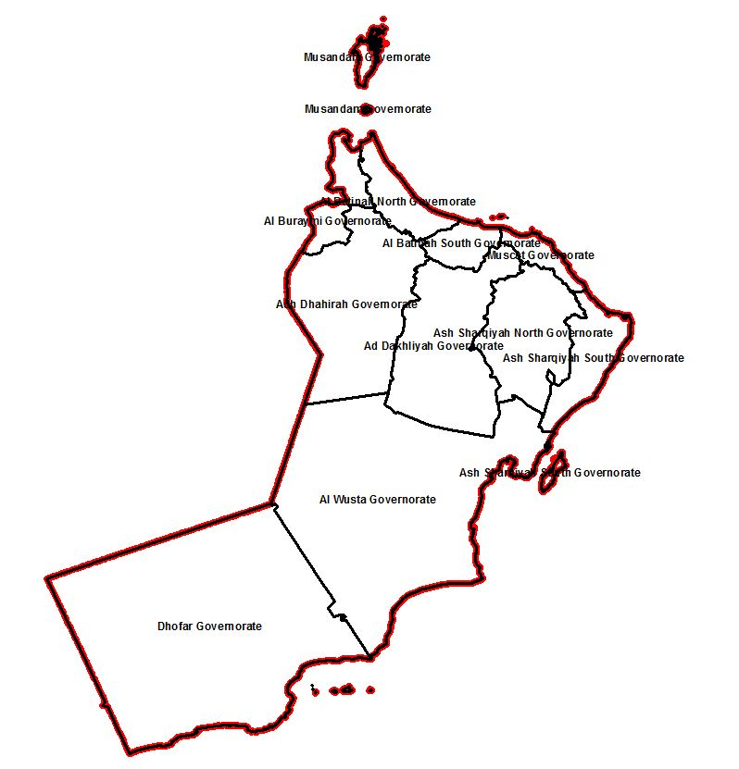

• Point of Origin

It is the reference point for each Governorate which needs to be referred for deciding the flow of direction for addressing.

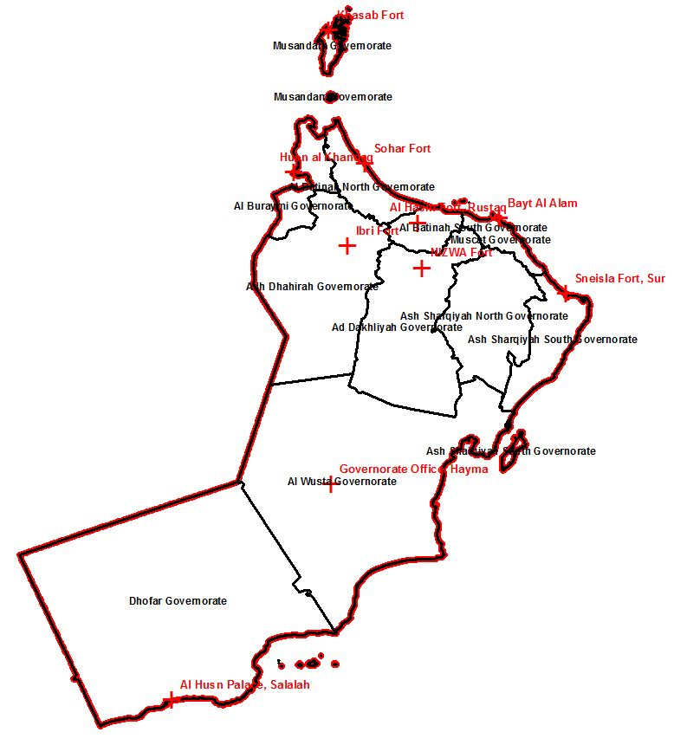

• Administrative Validity Area (Wilayat)

Each Governorate will be again be divided in to number of Wilayats. The entire Sultanate of Oman contains 61 Villages.

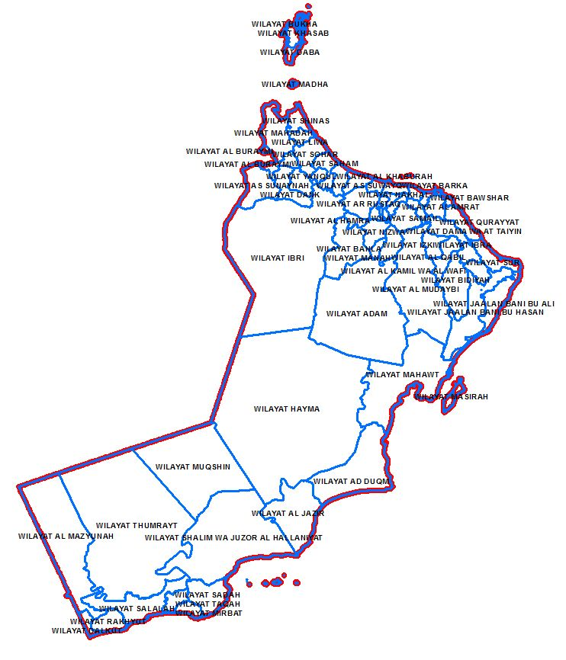

• Streets

A Street is a set of connected road surfaces and walkable paths at provided access to or transit between n public delivery points for goods, services or people.

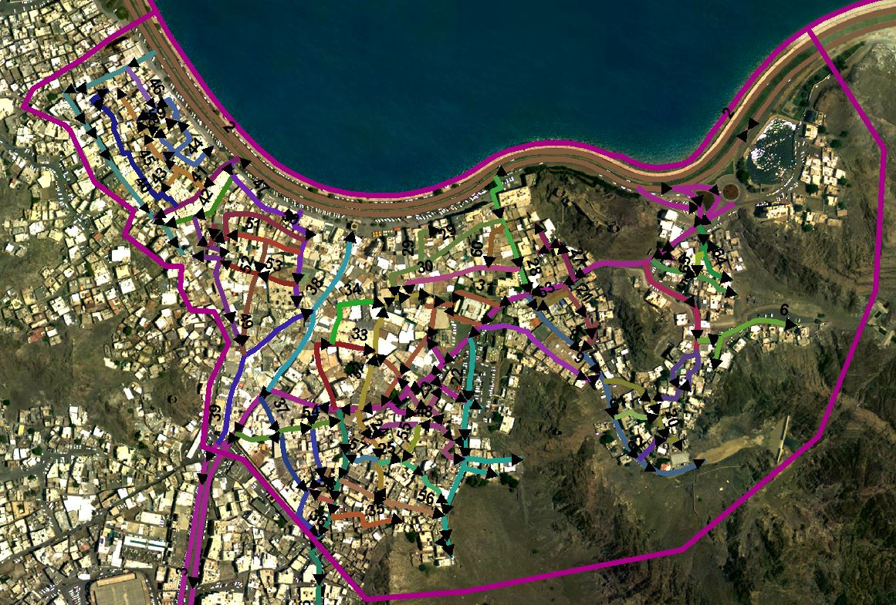

• Address Units

The address unit in the unified addressing system is defined as public delivery locations for goods, services and/or people. 'Public' means before entering the private domain, i.e. the entrance door to a building, the entrance to a gated compound, the shared gate of two villas etc. Sequential address unit numbers are assigned to addressable objects along streets.

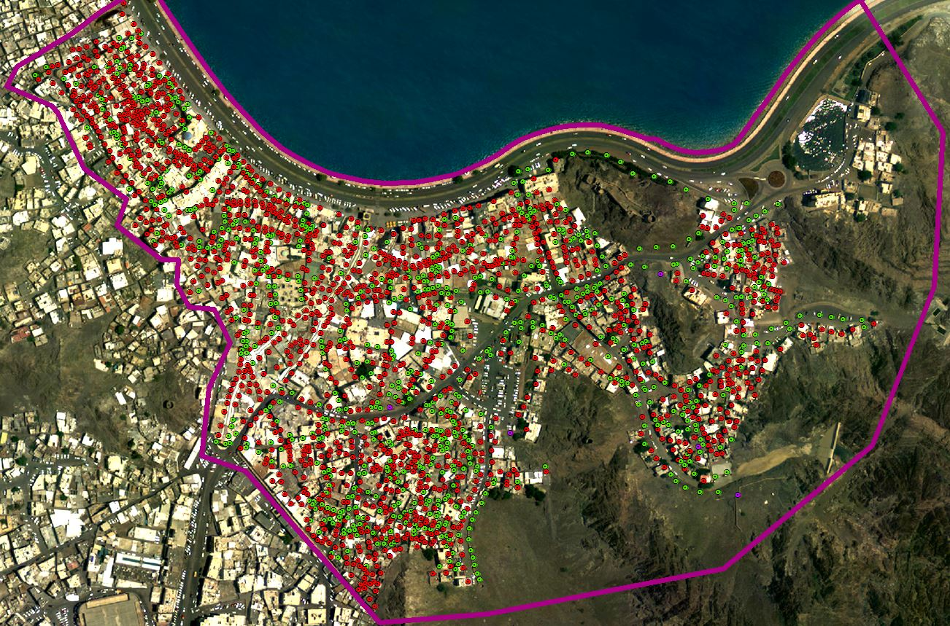

• Sub Address for Multi-dwelling Units

Whenever an address unit number is assigned to a public entrance that gives access to more than one functional unit, this unit will be considered a sub address. The most typical example of sub addresses are residential multi-store buildings with apartments and offices or gated residential compounds with villas or multi-unit buildings inside.

• Metering

Wherever there is no addressable unit exist along the road (or one side of the road), then we need to adopt this metering by deciding specific length with respective to the typical size of the available building in that location.

**Types of Rules**

There are 3 types of rules to be followed while following the Addressing specification.

The data capture instructions consist of three different types of rules:

"**Must rules**": mandatory rules that always are observed

"**Should rules**": important rules that should not be deviated from unless there is good reason. If a

"Should rule" must be broken often it is necessary to define a systematic exception to be applied each

time.

"**May rules**": rules that should be followed if possible/necessary but that may be omitted subject to

Interpretation

**Definition and Main Rules for streets segmentation in Unified Addressing system**

In the unified addressing system, a street is a set of connected road surfaces and walkable paths that provides access to or transit between public delivery points for goods, services or people. An address in the Sultanate of Oman is unique by the combination of an address unit number, a named street / or a named area and an administrative validity area. Street is also used as a specific term for local access roads in urban areas, however in this document, streets include everything from motorways down to pedestrian lanes.

Before considering the different segments of road centerlines in to one street segment, switch on/off data and check for the continuity with respective to the surface, flow of the road and check even with Google earth also for reference.

Main Rules

a. Streets must consist of one or more connected line segments

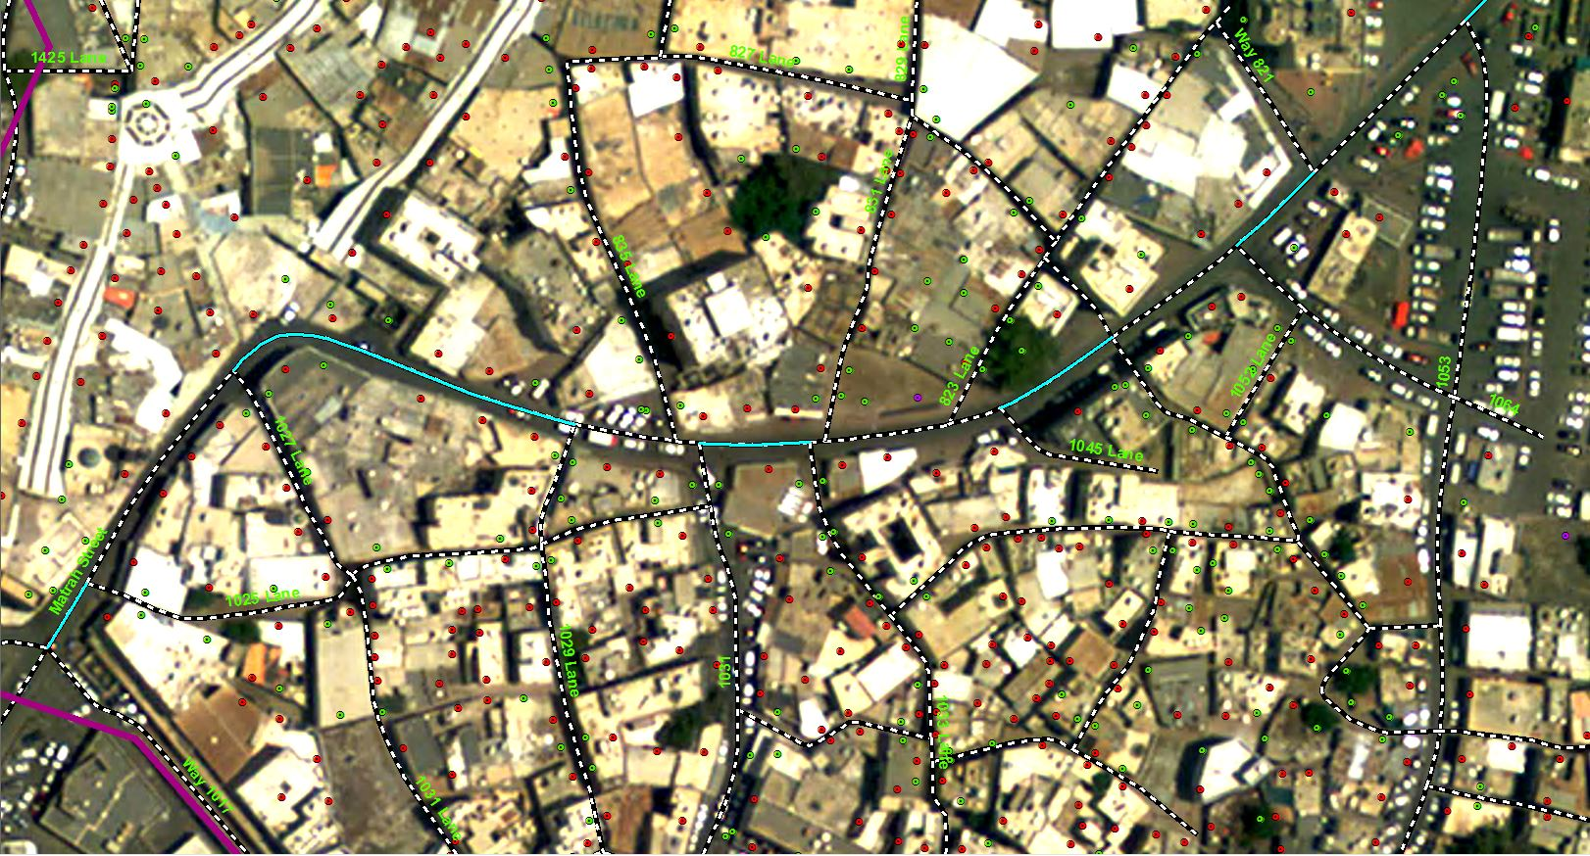

• Street line segments are copied from existing sources (existing base map).

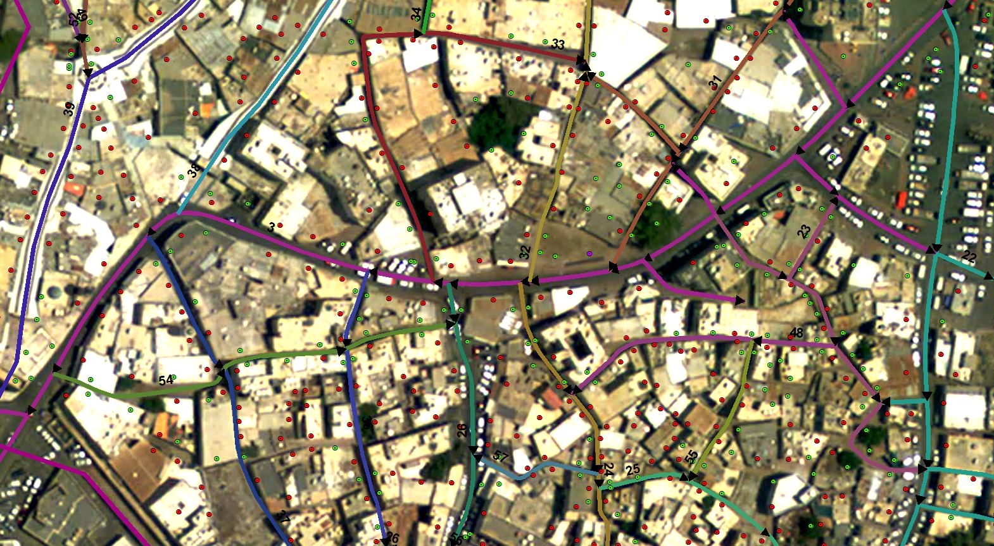

• If streets are evident in recent imagery but absent from vector data sources, new street geometries must be head on digitized on the screen.

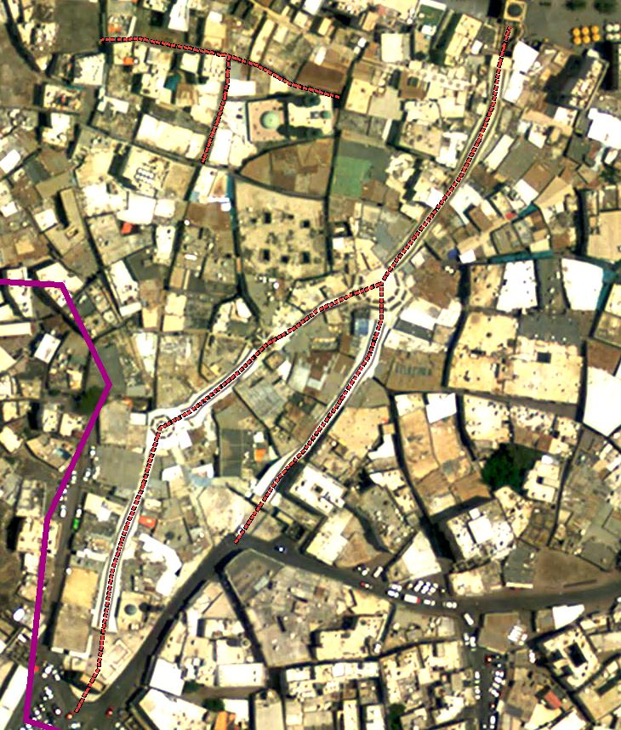

58°33'48.502"E 23°37'8.647"N

b. Streets must not have gaps and must be accessible from end-to-end.

• Intersections, bridges, fly-overs, culverts and tunnels are considered as regular street segments that are chained into addressing streets. The bridge and/or fly-over feature is kept as a separate geometry. Such elements may carry names. If these names are commonly used and relevant for way-finding, they may be added to the destination hierarchy.

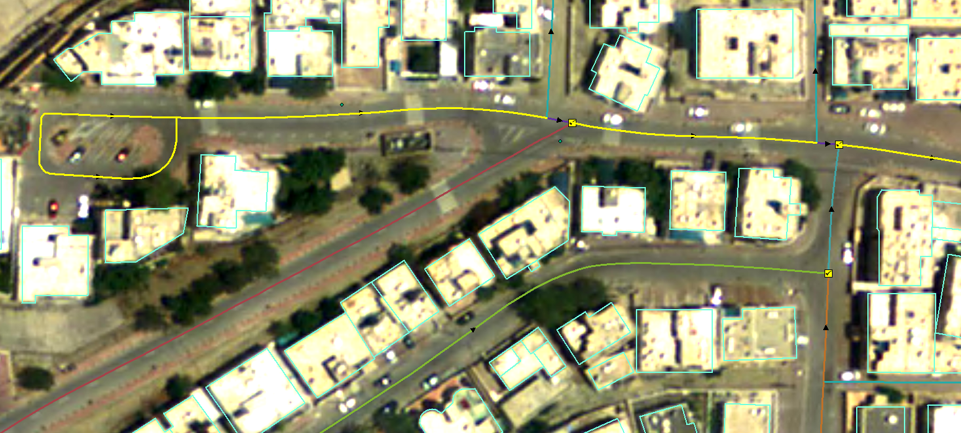

c. Streets must have a starting point to define its numbering direction

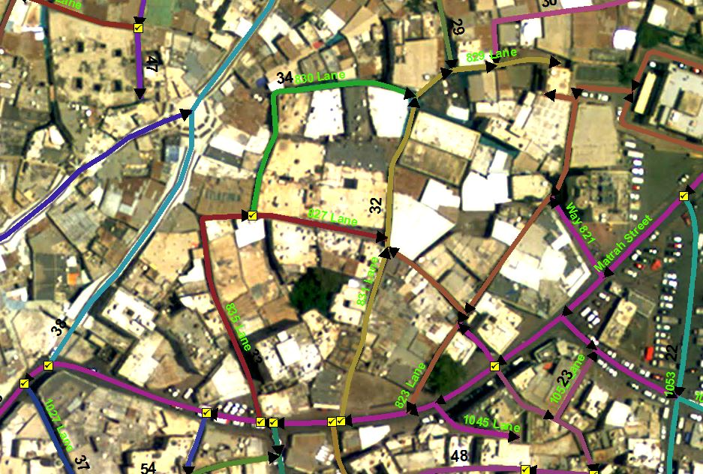

• The starting point for motorway and arterial streets should be the end of the street that is closest to the point of origin for the addressing jurisdiction area.

• The starting point for collector streets should be the exit from an arterial street and in the event of multiple exits, the exit closest to the point of origin.

• The starting point for local streets should be exit from the collector street

• Open ended streets must always be numbered in ascending order from the closed to the open end to leave room for future expansion of a street.

• Streets that run parallel to each other in the same area should have the same numbering direction.

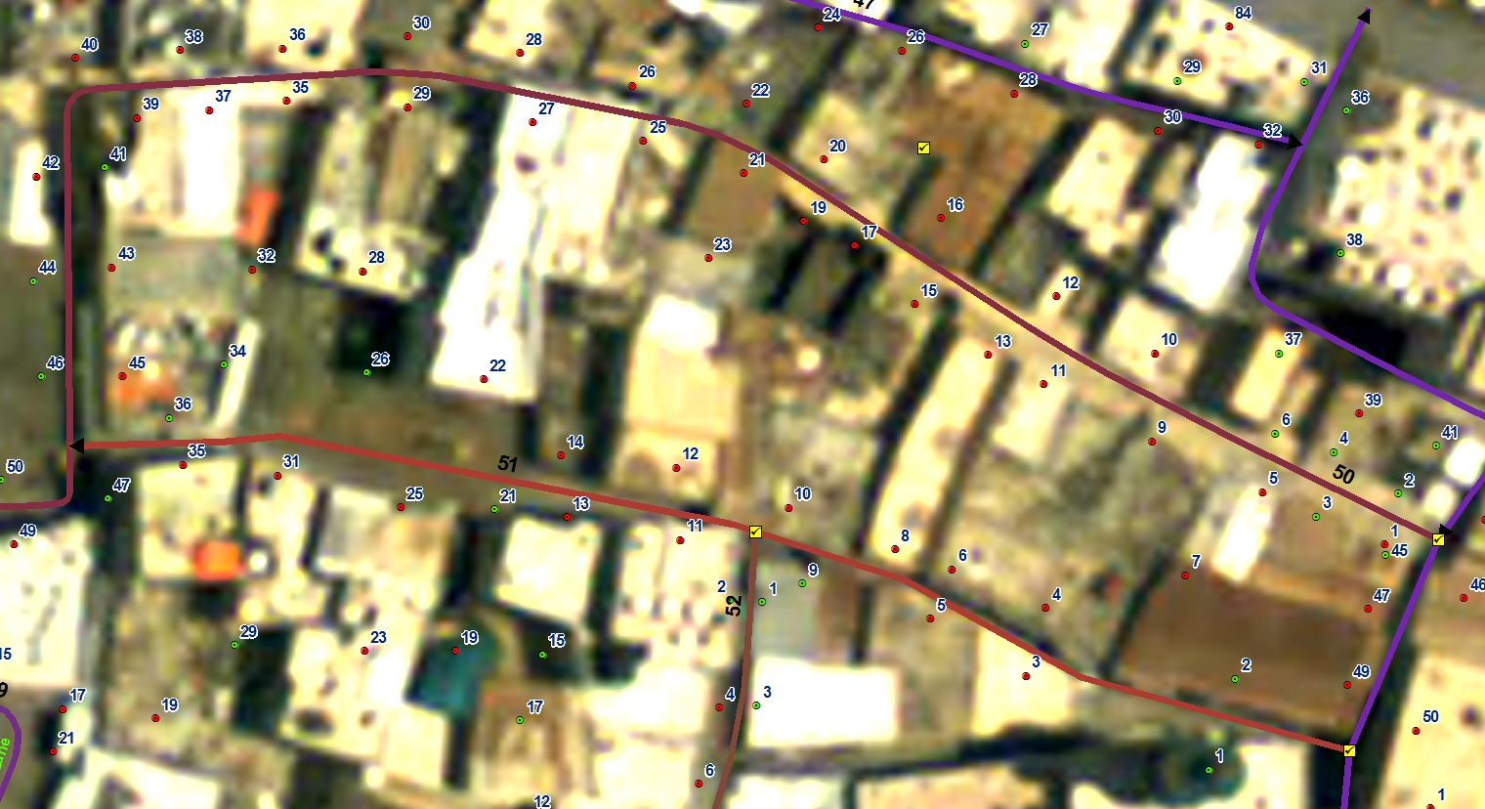

• For streets that cross Governorate boundaries where the direction of the street cannot be determined based on the above rules, the starting point should be defined based on the end D1.3 Technical specification for addressing data population in closest proximity to the point of origin in the Governorate that contains the greatest number of existing and/or approved planned addressable objects along the respective street.

d. Streets must have a unique identifier

• The unique identifier must be used during the naming process to assign names to defined streets.

• The unique identifier must be a numeric value that is unique within each municipality's production database. The identifier will be auto- generated by the system.

e. Streets must be given a name that is unique within the administrative validity area

• The name should be kept if the street passes from one governorate into another if it is a continuous street without any natural division point

• In this event the street name must not be used again in either governorate

• Names for streets identified by unique numerical identifiers should be proposed and approved by Municipal Councils in each governorate.

f. Street geometries must include roundabouts in order to provide continuous drivable surfaces

• Roundabouts do not need to be named unless they are on court-yards or plazas with addresses directly on them. In such cases they are named as ordinary streets.

• The street name attribute can be used to store the name of roundabouts that have existing names

g. Street geometries must not include service roads, laybys or other drivable surfaces that are not intended for local access

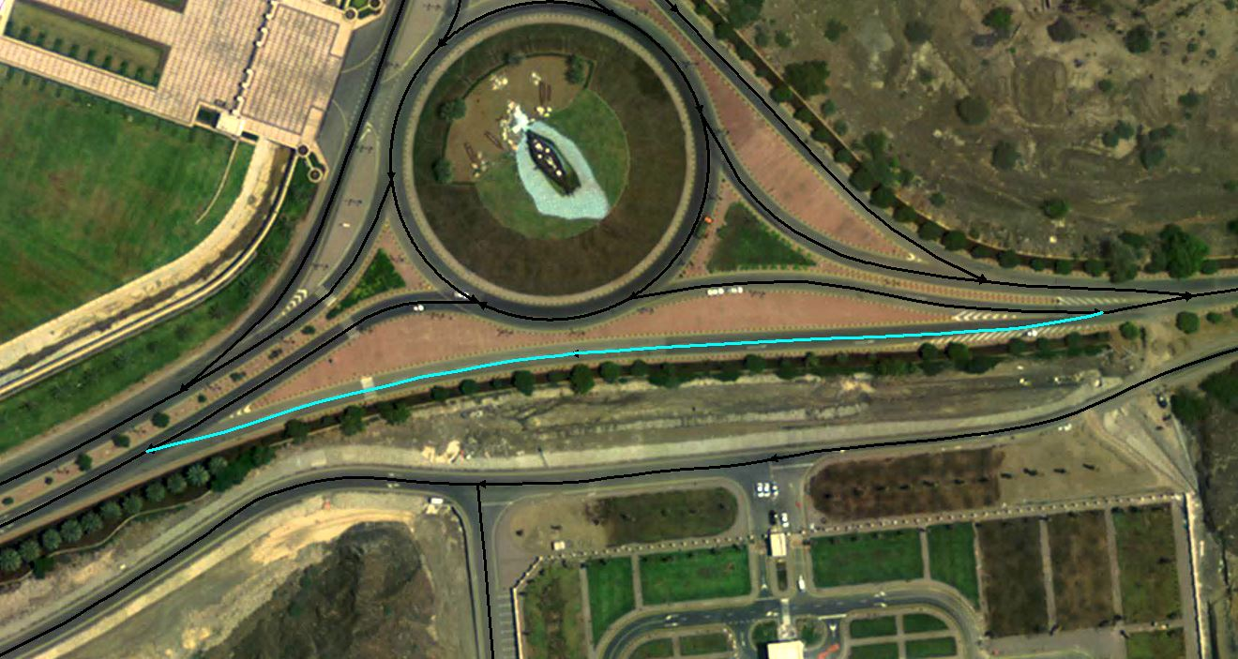

58°36'30.987"E 23°34'0.973"N

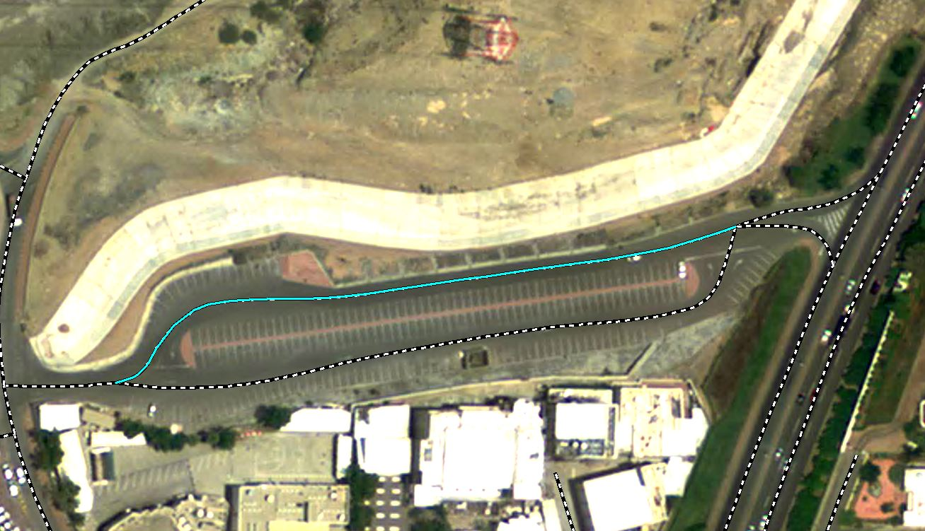

58°32'10.812"E 23°36'26.503"N

• The operator will select only relevant geometries from source layers at the time of populating the street dataset.

h. Streets must be classified

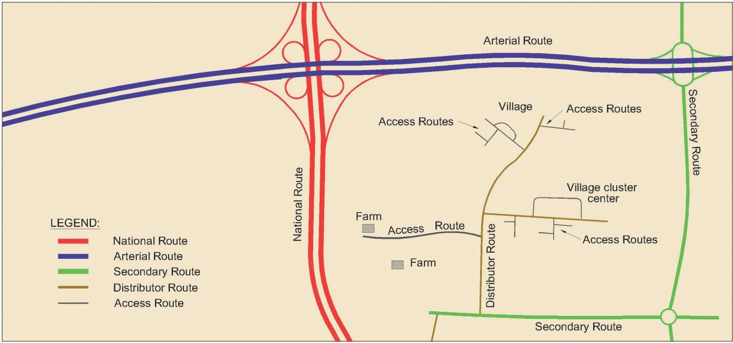

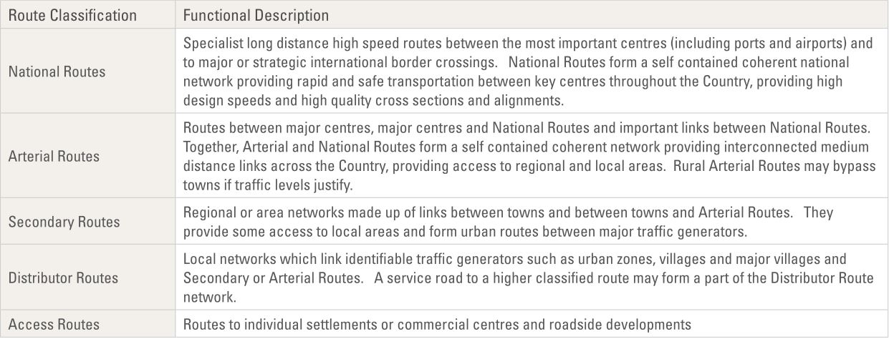

• A category for the entire street must be assigned based on the lowest service level the street provides for traffic along its extent. I.e. if a street along some sections provides access to individual address units but in other places have the character of a highway or motorway, it is should be classified and numbered as a local access street. The classification for streets is based on an extension of the road classification standard of the MoTC.

• Street segments must inherit the street classification that is used in the data source that the geometries are copied from. Street segments belonging to the same street can have different classifications based on road design standards and service levels.

i. A street should include connected cul-de-sacs D1.3 Technical specification for addressing data population

• Cul-de-sacs are short streets that do not provide transit but must be exited from the same end as it is entered.

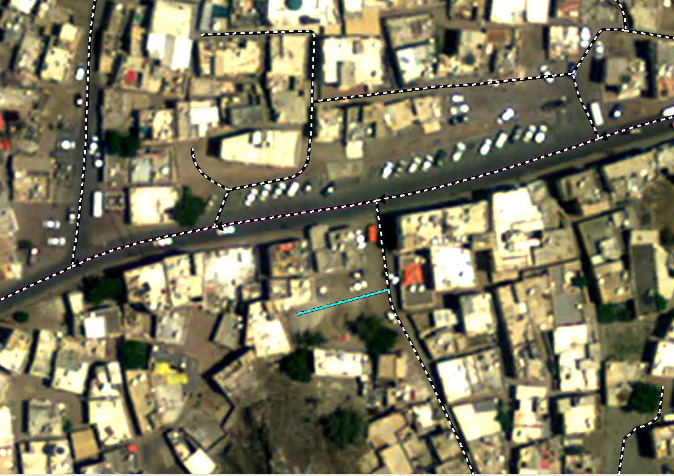

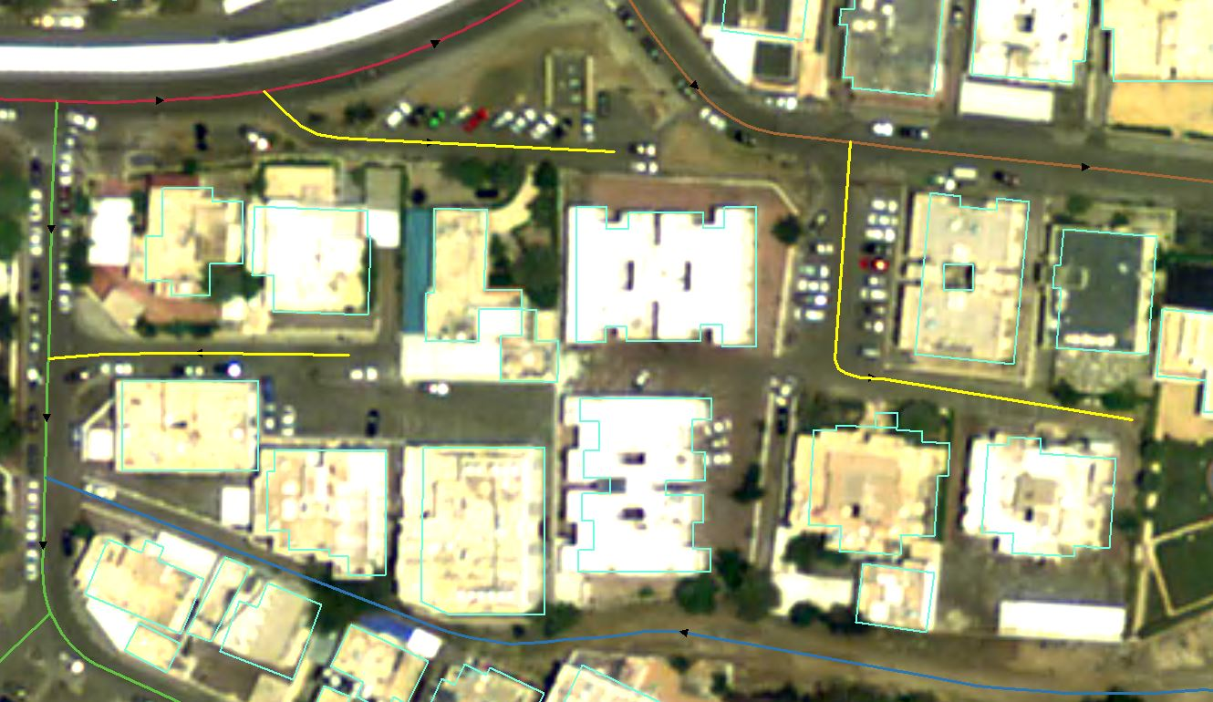

• Cul-de-sacs should be included in the street they are connected to if they are shorter than ~100 m

• The distance is not absolute and judgment should be exercised.

• Depending on the nature of the street, 100 meters may be too long or too short.

• A longer street segment that is visibly inferior to the road it is connected to could well be included connected

• All cul-de-sacs with a length greater than 100 meters but shorter than 200 meters should be assessed on a case to case basis

• A shorter street segment that has symbolic value can be considered as an independent street

j. Streets should not have self-intersections

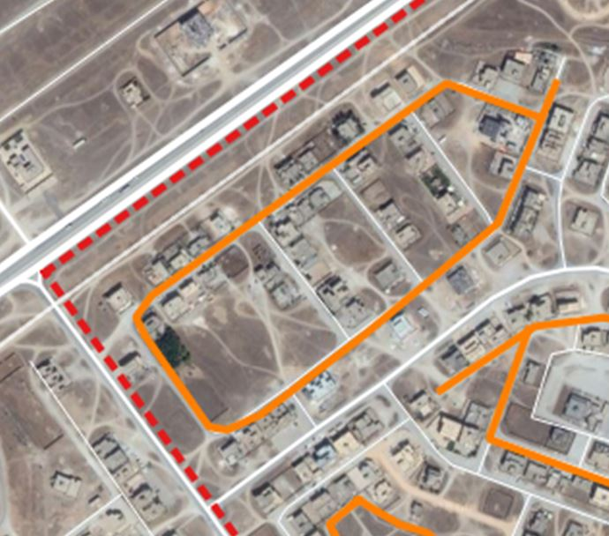

• T-intersections resulting from consolidating cul-de-sacs and connector streets into the street they are connected to must not be considered self-intersections

k. Streets may have a defined end-point

• The end-point must be added if a street changes its name at an intersection or other place where it does not need to change its name.

• If deemed useful for any purpose, an end-point may be added for any street.

• The end-point may be omitted for open-ended streets that cancan still be extended

Exceptions

1. A Street may be split at a roundabout, bridge, fly-over, tunnel or major landmark if it is useful for avoiding self-intersects.

2. A Street may be split at an X-intersections with major streets

3. A Street may include crescent shaped loop streets

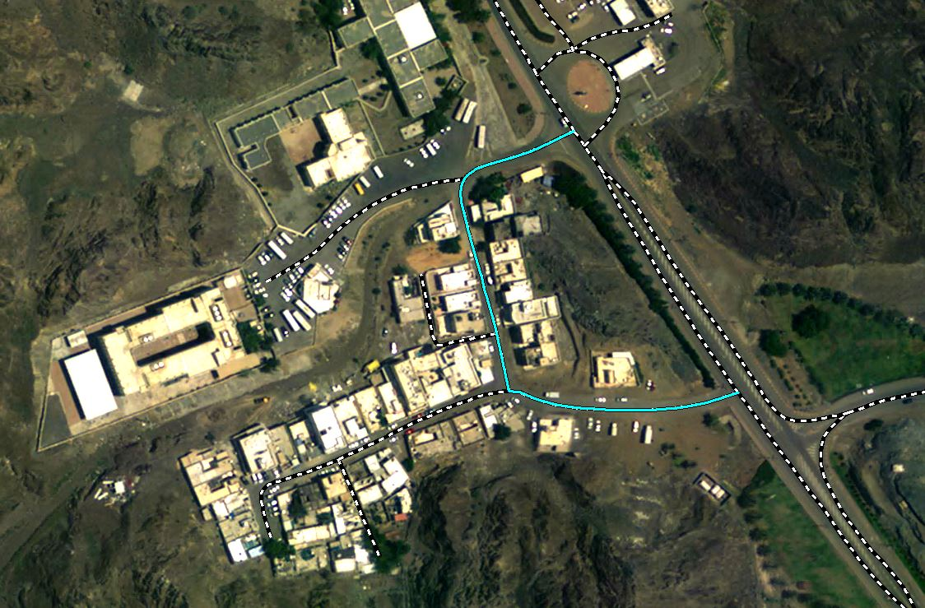

58°35'57.436"E 23°35'20.967"N

4. A Street may end in or extend as a track or path

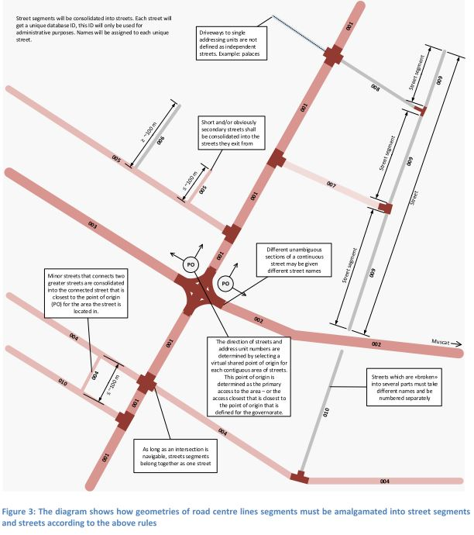

If there are addressable objects that are built according to a plan but the local access streets have not yet been built, it is necessary to draw new street features that these addressable objects can be numbered along.

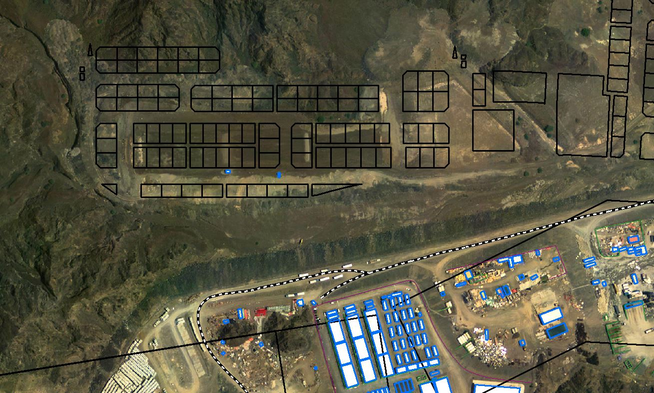

**Wrong street segmentations Examples**

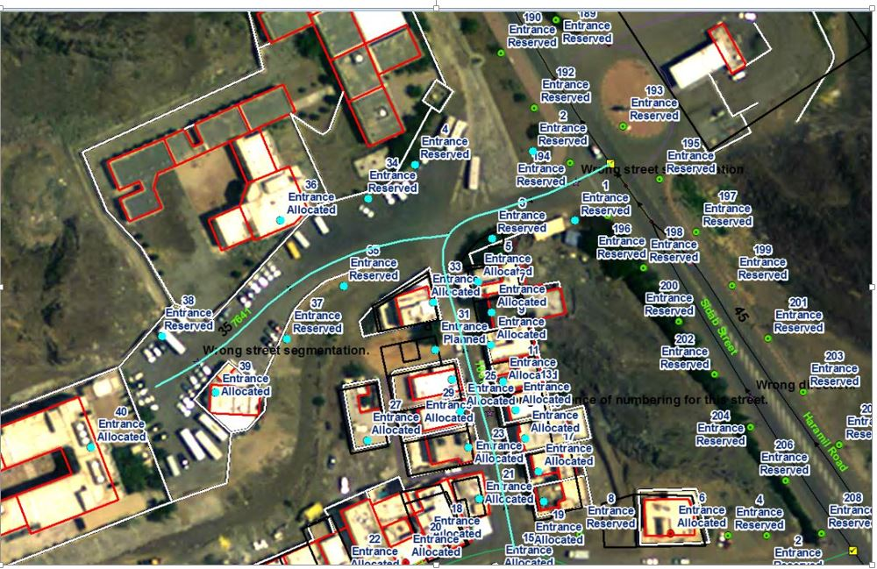

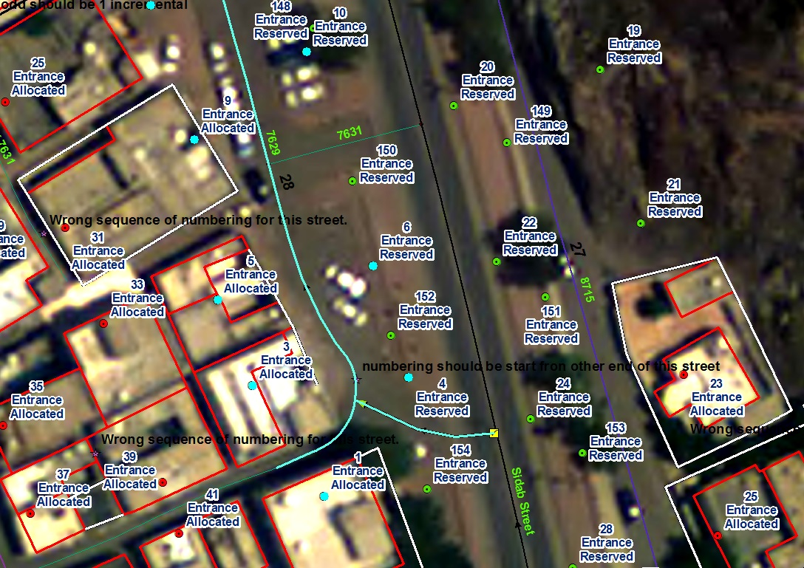

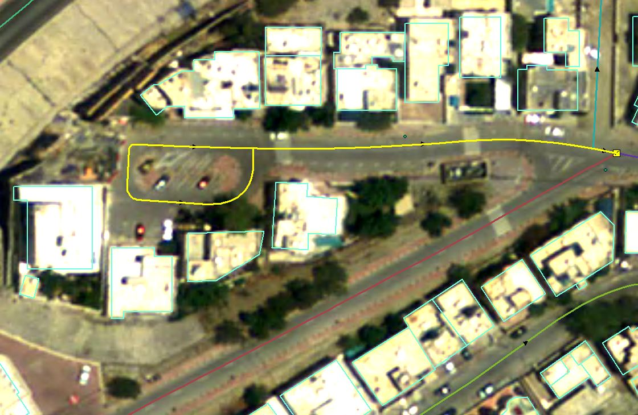

58°33'1.68"E 23°37'23.005"N

We cannot always consider a shorter ending street (less than 100m) as a cul-de-sac but should see if it has more number of addressable objects available for it then should consider it as a separate street only.

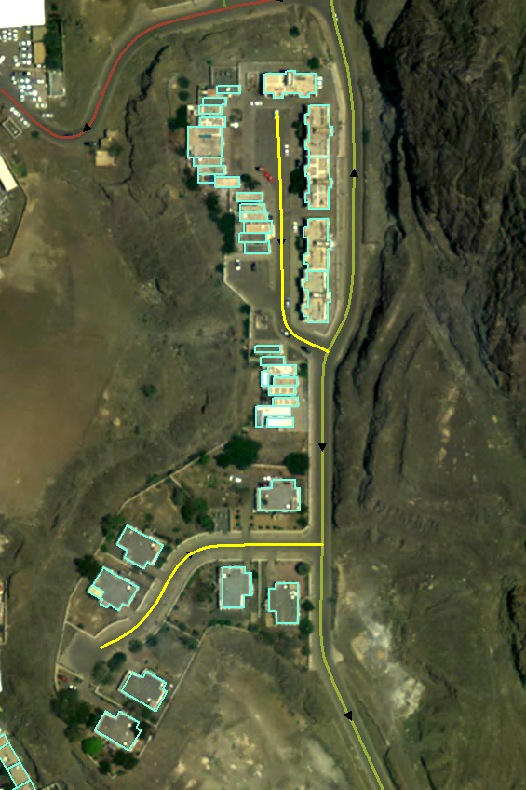

**ADDRESS UNITS**

The address unit in the unified addressing system is defined as public delivery locations for goods, services and/or people. 'Public' means before entering the private domain, i.e. the entrance door to a building, the entrance to a gated compound, the shared gate of two villas etc. Sequential address unit numbers are assigned to addressable objects along streets.

**Main rules**

Address unit numbers must be assigned to addressable objects along streets in an ascending sequence from the beginning towards the end of the respective street

• Odd numbers must be used on the left-hand side of the street

• Even numbers must be used on the right-hand side of the street

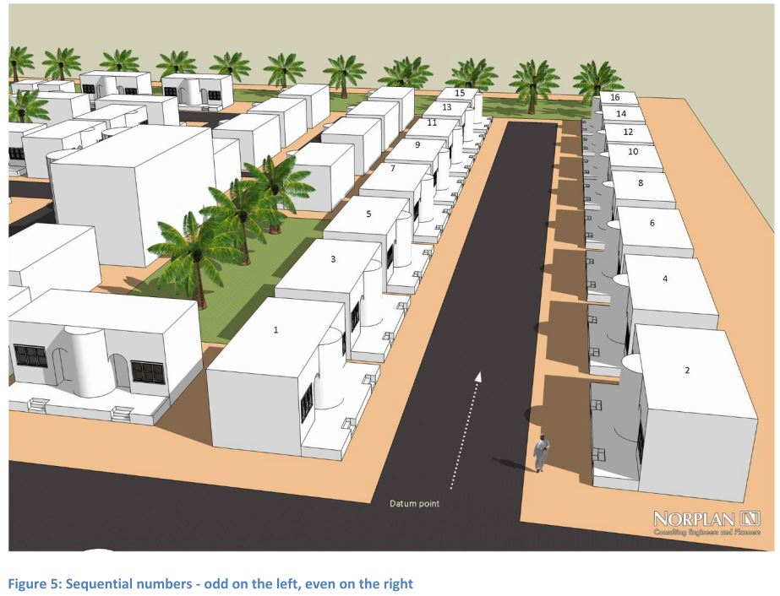

b. Address unit numbers must be reserved where there are no addressable objects but where they may appear in the future according to a metering principle

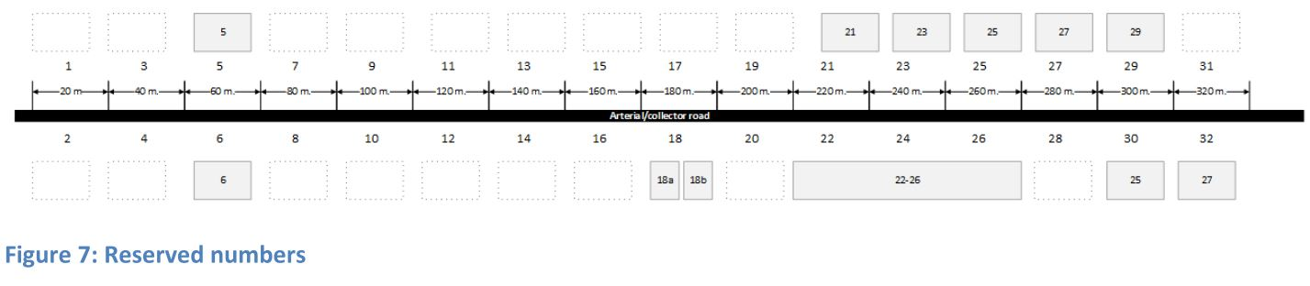

c. Addressable objects must be given an address unit number on the street that they are accessed from.

d. Addressable objects must reserve an address unit number on all streets that it has a frontage towards, if it has a frontage towards two or more streets.

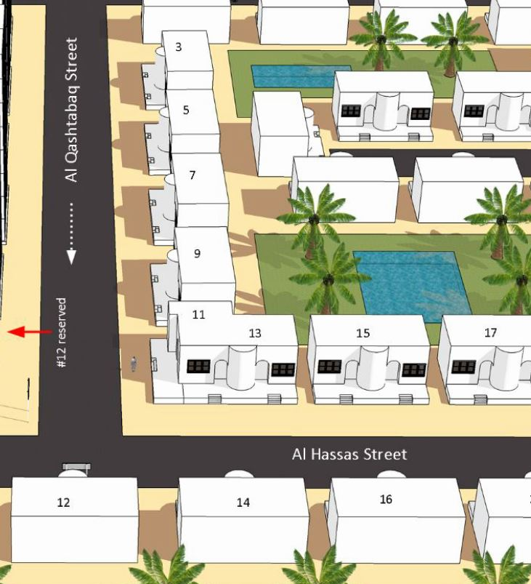

e. Address units must be reserved based on an address unit resolution that is determined for each street based on the planned and actual design of the area. The resolution should be defined following the first of the rules below that match:

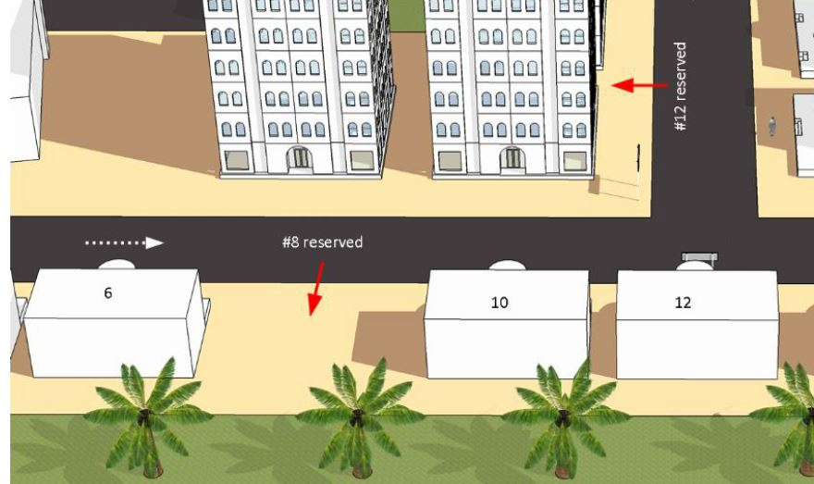

• In existing built-up areas, the resolution should equal the typical building street frontage

• In planned areas, the resolution should be set to the smallest typical street frontage of parcels. When determining the smallest typical plot size, plots for utilities, transformers etc. should be excluded.

• For areas without land use and parcel plans, the resolution should be set to the most commonly utilized plot size used in the Sultanate of Oman 3

For motorways and major highways, the design guidelines for the roads typically prohibits exits closer to each other than every two kilometers. An address unit resolution of 2000 meters should therefore be used for motorways/freeways

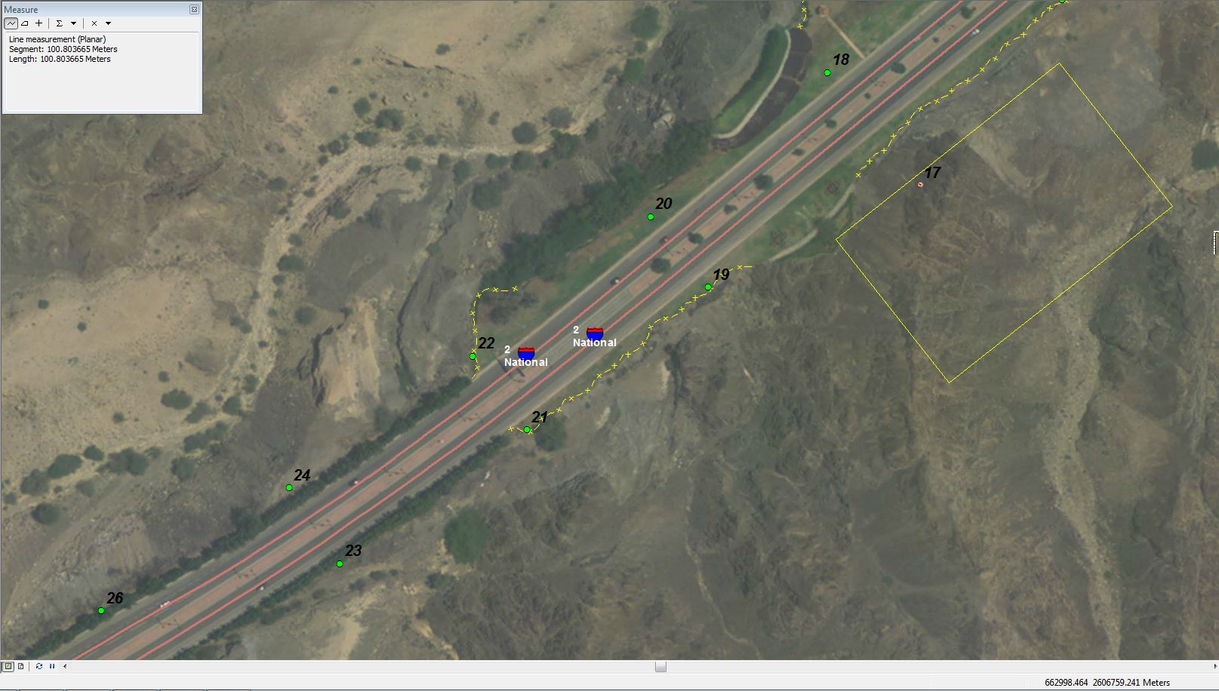

As we will be including cul-de-sac in to the parent road while creating street segment, the addressing for such streets should be followed as shown in the below screen shot.

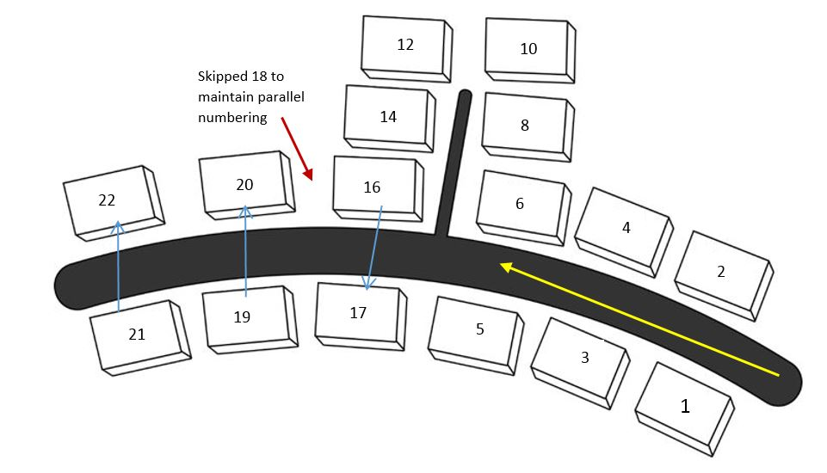

**Exceptions**

* If an addressable object is removed/demolished and replaced by two or more new addressable objects that are smaller than the address unit resolution used for the area, the address unit number may be subdivided using letters a-z.

a. The sequence of letters is less obvious than the sequence of numbers. It is therefore advisable to limit subdivision by letter to as few letters as possible

b. Eight is commonly used and manageable: a, b, c, d, e, f, g, h

c. Beyond eight letters it is more difficult to relate to the sequential order of the individual letters.

* If there are two or more rows of addressable object that share the same street access, the second row should be numbered as if it was merged with the front row as shown in Figure 16.

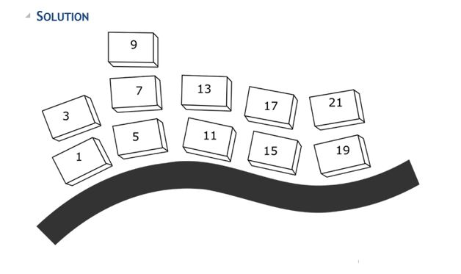

* If addressable objects are located on pedestrian paths inside mixed agricultural areas, the paths may be defined as cul-de-sacs or extensions of the street they exist from and addressable objects may be numbered to the resulting street.
* If addressable objects are in a port or on a shoreline without road access, they may be numbered to a named port, jetty, bay or beach instead of a street. D1.3 Technical specification for addressing data population

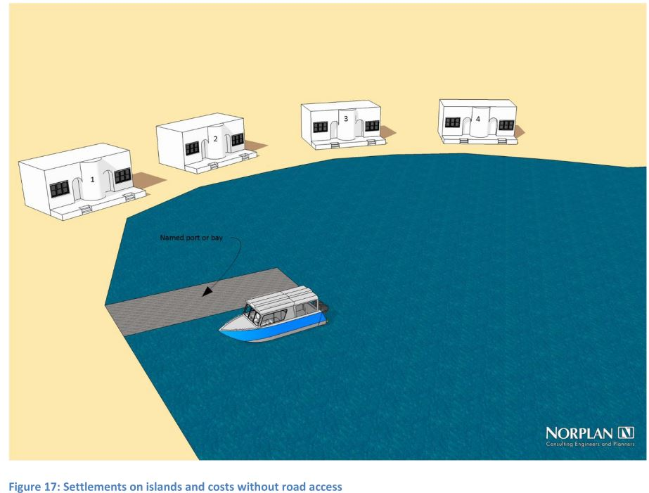

* Address units may be allocated to agricultural and industrial plots.

a. If the access to the plot is evident, the address unit number point must be placed inside the plot near to the entrance

b. If the access to the plot is not evident but it is possible to see from what side the plot will be accessed, the address unit number point must be placed inside the plot at the middle of the side from which it is entered

c. If the access point is not known, the address unit point may be assigned to the centroid of the plot

* If addressable objects do not have formal access and there are no plans, nor any de-facto 4 roads in the form of permanent tracks, address unit numbers may be allocated within an area instead of along a street.

a. The area should preferably be a town boundary from the National Centre for Statistics and Information 2010 census data.

b. Informal tracks and local access within such areas may be considered as one complex street with many branches.

c. Numbers should be allocated in a manner that preserves sequences and logic as well as possible but without an access infrastructure this is not always possible to achieve.

* Especially subsequent numbering of new structures in such areas is complicated as it is difficult to reserve addresses when the access is unknown. Addressing can provide exact locations but not compensate for impractical infrastructure.
* Single buildings or properties with a long driveway leading off a rural road must be numbered to the road they are accessed from with a directional sign at the exit.

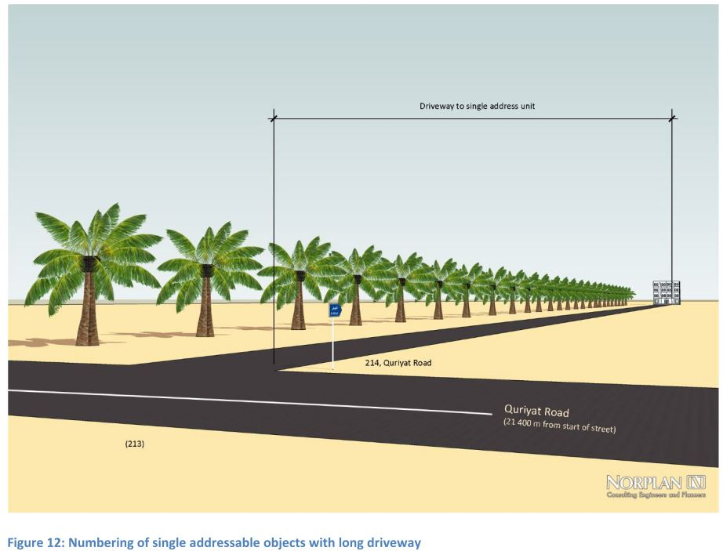

* Traditional Omani villages are abundant and are populated on a permanent or semi-permanent basis. Here, the addressable objects are located relative to the best agricultural areas and away from the wadi-beds rather than being organized along formal access roads. Houses are in clusters that range from highly compact to widely scattered.

In these cases, it is not feasible to number the addressable objects to streets but rather to give them a unique number within the named settlement.

For small groups of houses, a single circle counter-clock-wise numbering scheme may be applied.

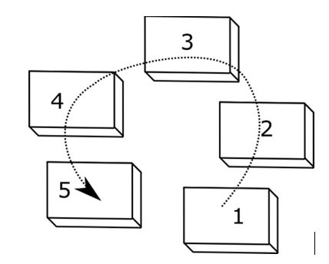

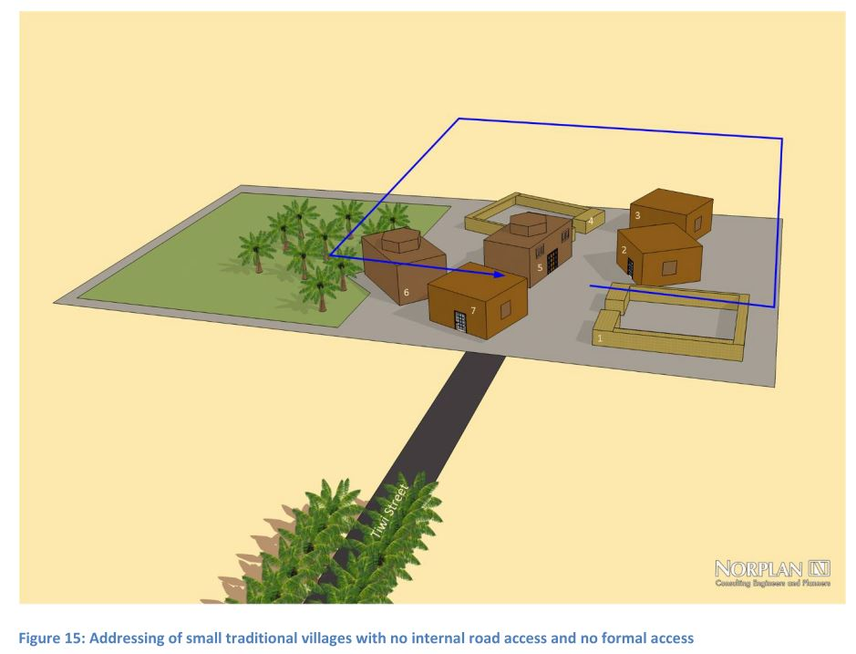

* Many older developed areas have addressable objects that are not connected to roads. The same is the case for individual residential and touristic addressable objects in the desert as well as on mountains.

Addressable objects are typically accessible by driving through dry wadi-beds or over flat expanses of compact gravel. Often no single track exists, but a variety of parallel tracks branch and merge.

For larger areas with irregular building patterns, a grid may be laid out with a cell-size adapted to the typical building size of the area. Each building will take the number of the cell it falls within. The direction of the numbering should be adapted to the closest access road.

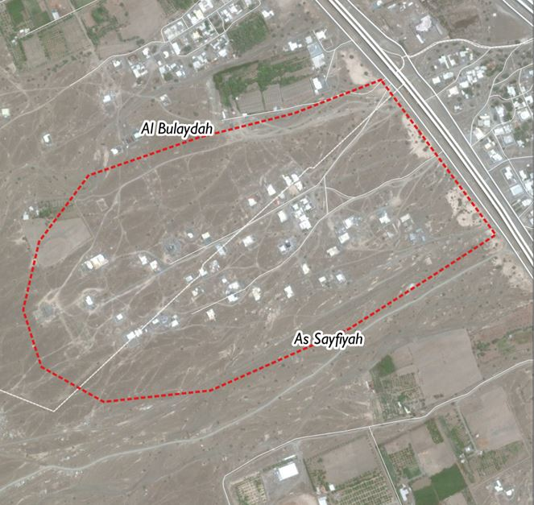

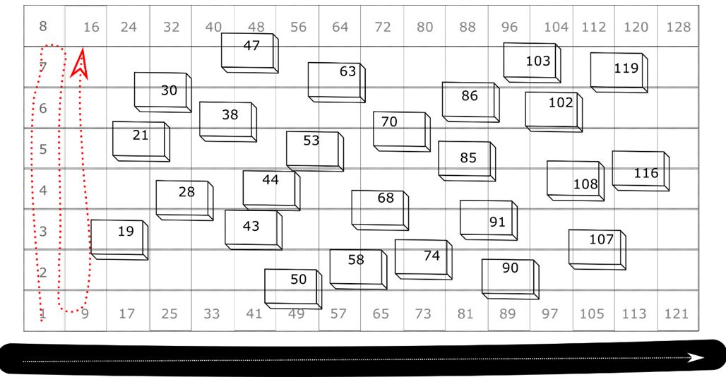

Wrong Addressing Examples:

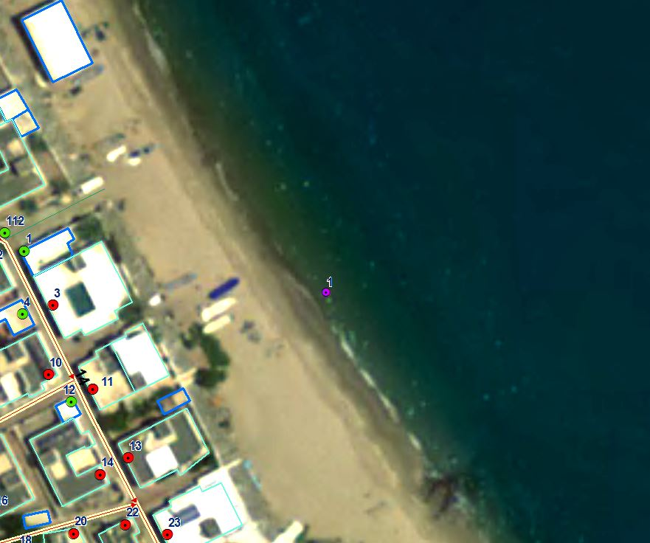

All the four buildings in the below screenshot are bounded within a single compound and hence should be treated as a single property and assign only one allocated address and can reserve addresses based on the metering.

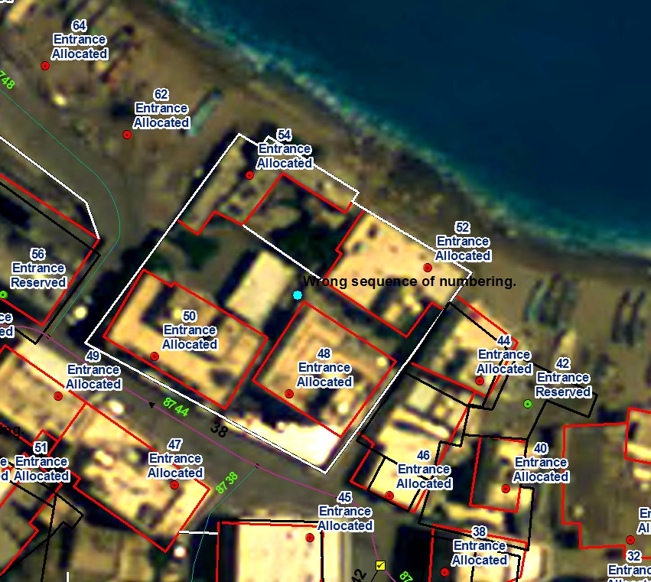

**Work inputs**

* Addressing template (working FGDB)
* New Centerlines (Feature Class)

**Reference**

* Work package Boundary
* Point of origin
* AOI
* Buildings (Base Map)
* Shaded Areas (Base Map)
* Road Center Lines (Base Map)
* Other Base Map
* Planned Data

MOH Parcels

REACO Parcels

Mazoon Parcels

* Input imagery
* Online Imagery